CHANGES HISTORY
PIC | Date | Remarks
Ghaida | 2018.04.20 | Created

TOC
- System ID
- Yearly
- Yearly Data
- Instrument ID Market
- Code Set
- Template ID
- ID Simpi
- Yearly Simpi Field
- Portfolio ID External
- Portfolio Field
- Portfolio Data
- Simpi Data
- Instrument ID External
- Code Set Simpi Field
- Code Set Simpi Data

Diagram ENTITY RELATIONSHIP

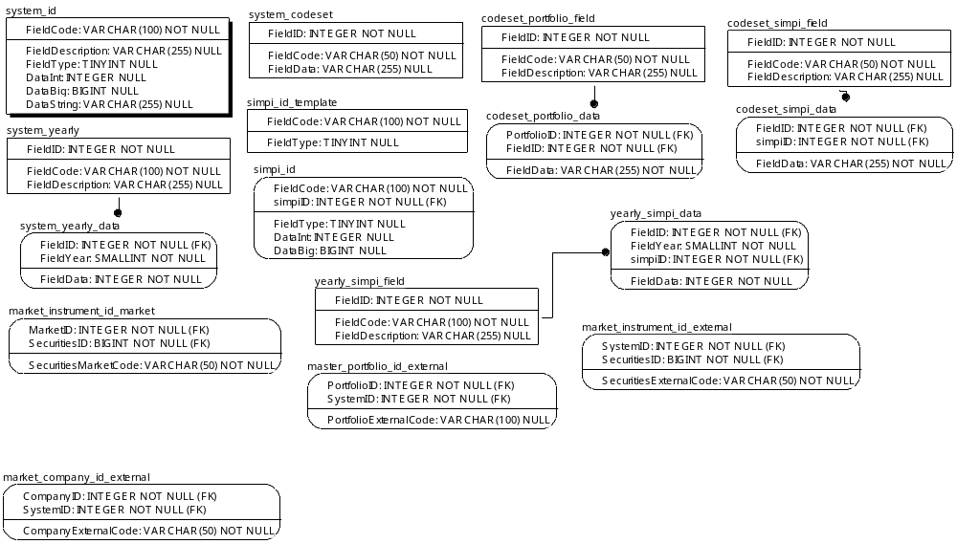

TABLE RELATIONSHIP
No | Table 1 | Table 2 | Type (1:1; 1:N; M:N) | Description
 | system_yearly | system_yearly_data | M:N
 | codeset_portfolio | codeset_portfolio_data | M:N
 | yearly_simpi | yearly_simpi_data | M:N
 | codeset_simpi_field | codeset_simpi_data | M:N

Name |  | system_id
Objective
No | Column |  | Type | Rule  (PK, FK, Key, NN, Unik, Index) | Description
1. | FieldCode |  | Varchar(100) | NN
2. | FIeldDescription |  | Varchar(255) | Null
3. | FieldType |  | TINYInteger | Null
4. | DataInt |  | Integer | Null
5. | DataBig |  | BIGInteger | Null
6. | DataString |  | Varchar(255) | Null

SAMPLE DATA
No | Column | Sample 1 | Sample 2 | Sample 3 | Sample 4
1. | FieldCode | ANALYST RECOMMENDATION | ANALYST VISIT | ANALYST VISIT FILE
2. | FIeldDescription
3. | FieldType | 1 | 1 | 1
4. | DataInt | 0 | 0 | 0
5. | DataBig | 0 | 2 | 0
6. | DataString

Name |  | system_yearly
Objective
No | Column |  | Type | Rule  (PK, FK, Key, NN, Unik, Index) | Description
1. | FieldID |  | Integer | NN
2. | FieldCode |  | Varchar(100) | NN
3. | FieldDescription |  | Varchar(255) | Null

SAMPLE DATA
No | Column | Sample 1 | Sample 2 | Sample 3 | Sample 4
1. | FieldID
2. | FieldCode
3. | FieldDescription

Name |  | system_yearly_data
Objective
No | Column |  | Type | Rule  (PK, FK, Key, NN, Unik, Index) | Description
1. | FieldID |  | Integer | NN
2. | FieldCode |  | Varchar(100) | NN
3. | FieldDescription |  | Varchar(255) | Null

SAMPLE DATA
No | Column | Sample 1 | Sample 2 | Sample 3 | Sample 4
1. | FieldID
2. | FieldCode
3. | FieldDescription

Name |  | market_instrument_id_market
Objective
No | Column |  | Type | Rule  (PK, FK, Key, NN, Unik, Index) | Description
1. | MarketID |  | Integer | FK
2. | SecuritiesID |  | BIGInteger | FK
3. | SecuritiesMarketCode |  | Varchar(50) | NN

SAMPLE DATA
No | Column | Sample 1 | Sample 2 | Sample 3 | Sample 4
1. | MarketID | 1 | 1 | 1 | 1
2. | SecuritiesID | 1 | 2 | 3 | 4
3. | SecuritiesMarketCode | AALI | ABBA.JK | ABDA.JK | ABMM.JK

Name |  | system_codeset
Objective
No | Column |  | Type | Rule  (PK, FK, Key, NN, Unik, Index) | Description
1. | FieldID |  | Integer | NN
2. | FieldCode |  | Varchar(50) | NN
3. | FieldData |  | Varchar(255) | Null

SAMPLE DATA
No | Column | Sample 1 | Sample 2 | Sample 3 | Sample 4
1. | FieldID
2. | FieldCode
3. | FieldData

Name |  | system_id_template
Objective
No | Column |  | Type | Rule  (PK, FK, Key, NN, Unik, Index) | Description
1. | FieldCode |  | Varchar(100) | NN
2. | FieldType |  | TINYInteger | Null

SAMPLE DATA
No | Column | Sample 1 | Sample 2 | Sample 3 | Sample 4
1. | FieldCode
2. | FieldType

Name |  | simpi_id
Objective
No | Column |  | Type | Rule  (PK, FK, Key, NN, Unik, Index) | Description
1. | FieldCode |  | Varchar(100) | NN
2. | simpiID |  | Integer | FK
3. | FieldType |  | TINYInteger | Null
4. | DataInt |  | Integer | Null
5. | DataBig |  | BIGInteger | Null

SAMPLE DATA
No | Column | Sample 1 | Sample 2 | Sample 3 | Sample 4
1. | FieldCode | BANK ACCOUNT | FUND BILLING ACCRUAL | GL JOURNAL TRANSACTION | GL LEDGER TRANSACTION
2. | simpiID | 1 | 1 | 1 | 819
3. | FieldType | 1 | 2 | 1 | 1
4. | DataInt | 0 | 0 | 0 | 0
5. | DataBig | 0 | 0 | 0 | 0

Name |  | yearly_simpi_filed
Objective
No | Column |  | Type | Rule  (PK, FK, Key, NN, Unik, Index) | Description
1. | FieldID |  | Integer | NN
2. | FieldCode |  | Varchar(100) | NN
3. | FieldDescription |  | Varchar(255) | Null

SAMPLE DATA
No | Column | Sample 1 | Sample 2 | Sample 3 | Sample 4
1. | FieldID
2. | FieldCode
3. | FieldDescription

Name |  | master_portfolio_id_external
Objective
No | Column |  | Type | Rule  (PK, FK, Key, NN, Unik, Index) | Description
1. | PortfolioID |  | Integer | FK
2. | SystemID |  | Integer | FK
3. | PortfolioExternalCode |  | Varchar(100) | Null

SAMPLE DATA
No | Column | Sample 1 | Sample 2 | Sample 3 | Sample 4
1. | PortfolioID | 50 | 50 | 51 | 51
2. | SystemID | 3 | 11 | 3 | 11
3. | PortfolioExternalCode | APPBCS | TP002MXCBALCRS00 | APPECS | TP002EQCEQTCRS00

Name |  | code_portfolio_field
Objective
No | Column |  | Type | Rule  (PK, FK, Key, NN, Unik, Index) | Description
1. | FieldID |  | Integer | FK
2. | FieldCode |  | Varchar(50) | FK
3. | FieldDescription |  | Varchar(255) | FK

SAMPLE DATA
No | Column | Sample 1 | Sample 2 | Sample 3 | Sample 4
1. | FieldID | 1 | 2 | 3 | 4
2. | FieldCode | UNIT PRICE DIGIT | BANK KUSTODIAN | RISK TOLERANCE | MAXIMUM UNIT
3. | FieldDescription | UNIT PRICE DIGIT | BANK KUSTODIAN | RISK TOLERANCE | MAXIMUM UNIT

Name |  | code_portfolio_data
Objective
No | Column |  | Type | Rule  (PK, FK, Key, NN, Unik, Index) | Description
1. | PortfolioID |  | Integer | FK
2. | FieldID |  | Integer | FK
3. | FieldData |  | Varchar(255) | NN

SAMPLE DATA
No | Column | Sample 1 | Sample 2 | Sample 3 | Sample 4
1. | PortfolioID | 50 | 50 | 50 | 50
2. | FieldID | 1 | 2 | 3 | 4
3. | FieldData | 2 | Standard Chartered Bank | Agresif | 10000000000.00

Name |  | yearly_simpi_data
Objective
No | Column |  | Type | Rule  (PK, FK, Key, NN, Unik, Index) | Description
1. | FieldID |  | Integer | FK
2. | FieldYear |  | SMALLInteger | NN
3. | simpiID |  | Integer | FK
4. | FieldData |  | Integer | NN

SAMPLE DATA
No | Column | Sample 1 | Sample 2 | Sample 3 | Sample 4
1. | FieldID
2. | FieldYear
3. | simpiID
4. | FieldData

Name |  | market_instrument_id_external
Objective
No | Column |  | Type | Rule  (PK, FK, Key, NN, Unik, Index) | Description
1. | SystemID |  | Integer | FK
2. | SecuritiesID |  | BIGInteger | FK
3. | SecuritiesExternalCode |  | Varchar(50) | NN

SAMPLE DATA
No | Column | Sample 1 | Sample 2 | Sample 3 | Sample 4
1. | SystemID | 1 | 1 | 1 | 1
2. | SecuritiesID | 1 | 2 | 3 | 4
3. | SecuritiesExternalCode | AALI.JK | ABBA.JK | ABDA.JK | ABMM.JK

Name |  | codeset_simpi_field
Objective
No | Column |  | Type | Rule  (PK, FK, Key, NN, Unik, Index) | Description
1. | FieldID |  | Integer | NN
2. | FieldCode |  | Varchar(50) | NN
3. | FieldDescription |  | Varchar(255) | Null

SAMPLE DATA
No | Column | Sample 1 | Sample 2 | Sample 3 | Sample 4
1. | FieldID | 1 | 2 | 3 | 4
2. | FieldCode | DMS Method | DMS Path | DMS User | DMS Password
3. | FieldDescription | DMS Method | DMS Path | DMS User | DMS Password

Name |  | codeset_simpi_data
Objective
No | Column |  | Type | Rule  (PK, FK, Key, NN, Unik, Index) | Description
1. | FieldID |  | Integer | FK
2. | simpiID |  | Integer | FK
3. | FieldData |  | Varchar(255) | NN

SAMPLE DATA
No | Column | Sample 1 | Sample 2 | Sample 3 | Sample 4
1. | FieldID | 1 | 1 | 811 | 811
2. | simpiID | 1 | 2 | 1 | 3
3. | FieldData | test | tesdfg | Windows Network Share | juna94

